Shashank Sarma
2019130053
TE COMPS
CSS Lab

Experiment 1

Aim:
To implement Substitution, ROT 13, Transposition, Double Transposition and Vernam Cipher in Python.
Code:
import math

print('1) Substitution')
print('2) ROT 13')
print('3) Transpose')
print('4) Double Transposition')
print('5) Vernam Cipher')
a =int(input('Enter the cryptography method:'))

def encryptBySubstitution(text,shift = 1):
cipher = ""
shift = shift%26
for letter in text:
if(ord(letter)>96 and ord(letter)<=122):
new_value = (ord(letter) + shift)
if(new_value > 122):
new_value -= 26
cipher += chr((96 + new_value)%96 + 96)
elif(ord(letter)>64 and ord(letter)<=90):
new_value = (ord(letter) + shift)
if(new_value > 90):
new_value -= 26
cipher += chr((65 + new_value)%65 + 65)
else:
cipher +=chr(ord(letter) + shift)

return cipher

def decryptBySubstitution(text,shift = 1):
cipher = ""
shift = shift%26
for letter in text:
if(ord(letter)>96 and ord(letter)<=122):
new_value = (ord(letter) - shift)
if(new_value < 97):
new_value += 26
cipher += chr((96 + new_value)%96 + 96)
elif(ord(letter)>64 and ord(letter)<=90):
new_value = (ord(letter) - shift)
if(new_value < 65):
new_value +=26
cipher += chr((64 + new_value)%64 + 64)
else:
cipher +=chr(ord(letter) - shift)
return cipher

def encryptByVernam(text,key):
cipher = ""
for i in range(len(text)):
cipher += chr(((ord(text[i])-65)^(ord(key[i])-65))+65)
return cipher

def decryptByVernam(cipher,key):
text = ""
for i in range(len(cipher)):
text += chr(((ord(cipher[i]) - 65)^(ord(key[i]) - 65)) + 65)
return text

def encryptByTranspose(text,key):
col = len(key)
row = math.ceil(len(text)/col)
# print('The dimensions are: ',row,col,text)

matrix = []
for i in range(0,row):
string = []
for j in range(0,col):
string.append("_")
matrix.append(string)

# print('The constructed matrix is: ', matrix)

text_index = 0
for i in range(0,row):
for j in range(0,col):
matrix[i][j] = text[text_index]
text_index += 1
if(text_index >= len(text)):
break
if(text_index >= len(text)):
break

# print('The column matrix is: ', matrix)
refer_key = sorted(key)
# print('The sorted list is: ',refer_key)

cipher = ""
for i in range(0,col):
iterate_col_index = key.index(refer_key[i])
print(iterate_col_index)
key = key[:iterate_col_index] + '-' + key[iterate_col_index+1:]
print(key)
for j in range(0,row):
cipher += matrix[j][iterate_col_index]

return cipher

def decryptByTranspose(cipher,key):
col = len(key)
row = math.ceil(len(cipher)/col)

matrix = []
for i in range(0,row):
string = []
for j in range(0,col):
string.append("_")
matrix.append(string)
refer_key = sorted(key)
cipher_index = 0
for i in range(0,col):
iterate_col_index = key.index(refer_key[i])
key = key[:iterate_col_index] + '-' + key[iterate_col_index+1:]
for j in range(0,row):
matrix[j][iterate_col_index] = cipher[cipher_index]
cipher_index += 1
if(cipher_index >= len(cipher)):
break
if(cipher_index >= len(cipher)):
break

text = ""
for i in range(0,row):
for j in range(0,col):
# if(matrix[i][j] == "_"):
# continue
text += matrix[i][j]

return text

def filterText(text):
string = ""
for letter in text:
if(letter!="_"):
string+=letter
return string

if a == 1:
text = input('Enter Plain Text: ')
key = int(input('No of position to be shifted: '))
encrpytedText = encryptBySubstitution(text,key)
print('Encrypted Message',encrpytedText)
print('Decrypted Message',decryptBySubstitution(encrpytedText,key))

elif a == 2:
text = input('Enter Plain Text to be encrypted: ')
encrpytedText = encryptBySubstitution(text, 13)
print('Encrypted Message', encrpytedText)
print('Decrypted Message', decryptBySubstitution(encrpytedText, 13))

elif a == 3:
text = input('Enter Plain Text to be encrypted: ')
key = input('Enter key: ')
encryptedText = encryptByTranspose(text,key)
decryptedText = decryptByTranspose(encryptedText,key)
print("The encrypted cipher is: ",filterText(encryptedText))
print("The decrypted text is: ",filterText(decryptedText))

elif a == 4:
text = input('Enter Plain Text to be encrypted: ')
key1 = input('Enter key 1: ')
key2 = input('Enter key 2: ')
encryptedText1 = (encryptByTranspose(text,key1))
encryptedText2 = (encryptByTranspose(encryptedText1,key2))
decryptedText1 = decryptByTranspose(encryptedText2,key2)
decryptedText2 = decryptByTranspose(encryptedText1,key1)
print("The encrypted cipher is: ",filterText(encryptedText2))
print("The decrypted text is: ",filterText(decryptedText2))

elif a == 5:
text = input('Enter Plain Text to be encrypted: ')
key = input('Enter key of the same length as the Plain Text:')
while(len(text)!=len(key)):
key = input('Enter key of the same length as the Plain Text: ')
encryptedText = (encryptByVernam(text,key))
decryptedText = decryptByVernam(encryptedText,key)
print("The encrypted cipher is: ",(encryptedText))
print("The decrypted text is: ",(decryptedText))

Output:
Substitution
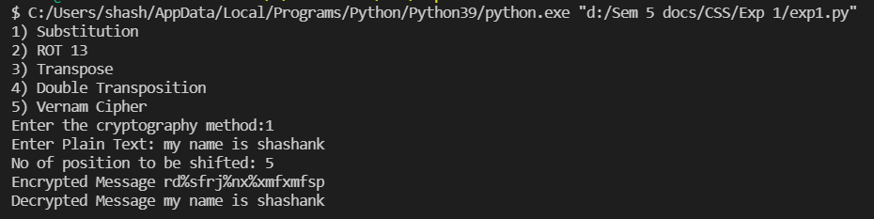

ROT 13
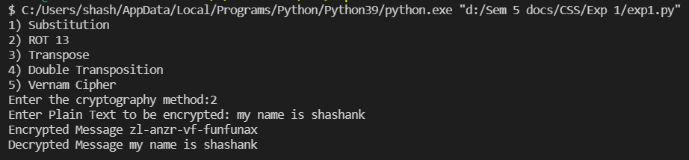
Transposition
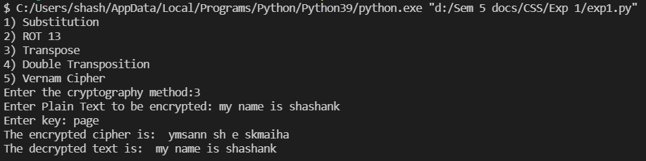
Double Transposition
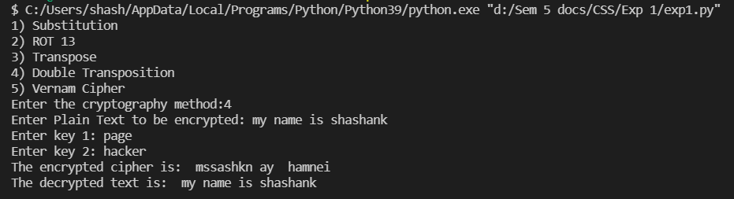

Vernam Cipher
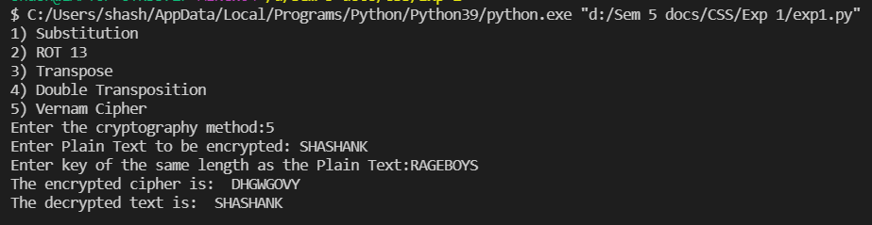

Conclusion:
In this experiment, I learned and implemented 5 methods of encryption using python. They are as follows:
Substitution: As the name suggests, Substitution algorithm substitutes all the characters in the plain text to some other character. A substitution cipher is a method of encrypting in which units of plaintext are replaced with the ciphertext, in a defined manner, with the help of a key. In my implementation, the key is replacing a particular character by another one by adding a particular value to its ASCII value. Substitution algorithm can be cracked as there are only finite values with which characters can be replaced with. Hence, this algorithm is not directly used in modern cryptography, but it lays the foundation for creation of complex cryptography algorithms.
Rot 13: This algorithm rotates the ASCII value of each alphabet by 13, in simple words it is a simple cipher that replaces a letter with the letter that comes 13 letters after it in the alphabet., and in a cycle i.e z would be substituted with M. Therefore, the implementation of this algorithm is similar to substitution algorithm whose observations are mentioned above. Here the shift/key value is fixed to 13 and as a result this algorithm could easily be cracked by a normal human by simply observing the pattern and hence the applications of this algorithm is limited.
Vernam: This algorithm encrypts each character with its corresponding character in the key, and therefore the length of the key must be the same as the length of the plain text. Since the value of the encrypted text is dependent on the key which is given as an input, the only way to crack the algorithm would be to try out various combinations until you decipher the key and during this process one would require strong computational power depending upon the length of the text. Because of all the factors mentioned above the applications of Vernam cipher is wide and active even in modern cryptography where the 8 bits word of a computer are encrypted in the similar manner as a 5-bit word of a teletype system( Vernam cipher was first used in early 1920s to encode the messages in teletype system).

Transpose: In this algorithm the input text is transformed into a matrix whose column length would depend on the length of the key which is taken as an input. The characters of the plain text are inserted row by row, with the column length being defined as the length of the key. In order to get the ciphertext using transposition, characters are taken from the matrix column by column, where the order of the column is decided by the key itself. In my implementation, the characters of the key are taken in order and the position of that particular character in the sorted key is the column which is chosen first. Transposition, unlike substitution, changes the position of the characters in a particular string and does not replace or substitute characters.

Double Transposition: In this algorithm, the transposition algorithm is applied twice to a particular plain text. The plain text is encrypted using transposition through key 1 and that encrypted text is further encrypted using transposition through key 2. Double Transposition helps in providing more security. A single transposition could be attacked by guessing possible column lengths, writing the message out in its columns (but in the wrong order, as the key is not yet known), and then looking for possible anagrams. Thus to make it stronger, a double transposition is often used.

